**Is Artificial Intelligence a “doomsday” or a “golden age”?**

Machine learning, Canon business blog, Artificial Intelligence, Internet of things

Artificial Intelligence (AI) stays at the top charts of innovative technologies since late 90s. Even before practical implementation it has been a popular sci-fi topic. There were two kinds of plots, either utopia-like society with life support being handled by smart robots or gloomy future with total AI control. These topics are at the base of ethical problems of artificial mind development. But first things first.

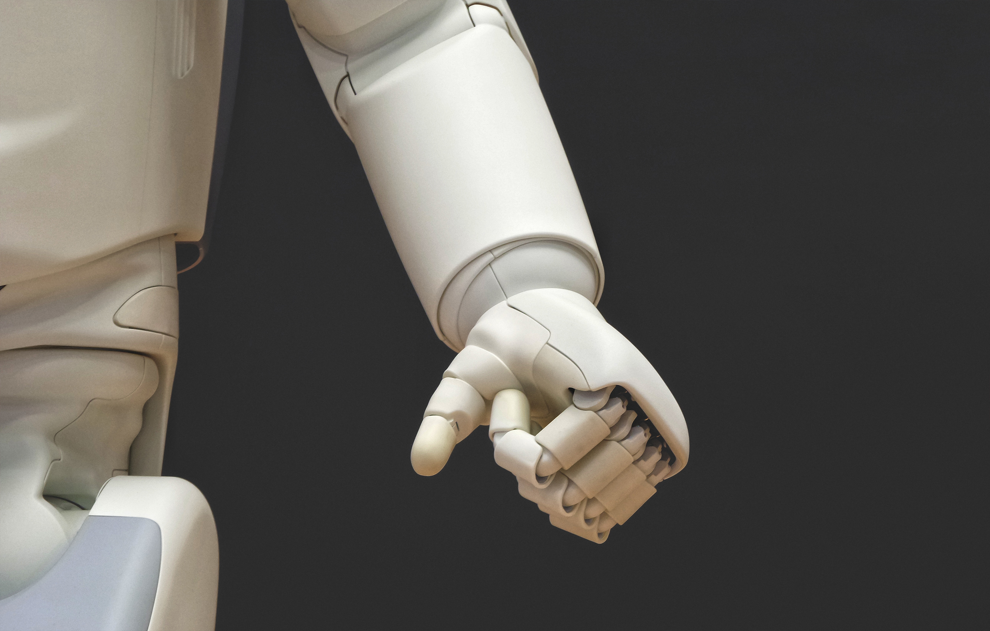

Programmers differentiate two main approaches for AI creation. The first one is a human brain simulation with complex neural network and nerve endings. Another is about a set of algorithms that follow human brain activity. At the dawn of AI development the first option was too complex to create because of weak computation capabilities and small theoretical base. Hence, algorithm approach had been chosen. However, not all tasks could be solved this way. In some cases the only solution available were neural networks. Therefore, they became the basis for machine learning. Modern computer technology development helps to make progress in neural network development.

Each of the artificial intelligence approaches had their own weak and strong sides. When the set of algorithms is developed, there is a necessity for each task to have its formal description. Hence, in order to widen the problems solved, the developer should add new algorithms. Nevertheless, such technologies were good at solving logical tasks, and no later than in the end of 90s computer won at the chess game against the world champion.



Artificial neural networks do not require programming in a way it is presented in algorithms development. The main advantage is that they are capable of self-development. Based on the big amount of correct answers, dependencies between input and output are constructed. The first task that was successfully solved was ‘item classification’ with a correct answer percentage close to the one that human has.

It can be assumed that the combination of both approaches may give better results. Actually, one of such hybrid results is Go game algorithm that outplayed human. The best from algorithms and neural networks had been combined. The AI calculated its board situation as ‘better’ or ‘worse’ and only then did algorithm calculate the outcomes of the options chosen by neural network as ‘good’.

There was no need in calculating everything. This might be compared to a human brain that intuitively classifies the situation, choosing the most optimal moves. Unfortunately, this hybrid approach isn’t always possible to implement.

The practical usage of artificial intelligence was preceded by a number of valuable studies. Computer data processing formed the environment of structured and standardized information. The usage of computer scripts led to lesser dependency for labor results from person’s qualification and soft skills. People adapted their way of life with modern technologies. That is why AI usage will more and more be a partial substitution for labor work.